Jeremia Faust

CS-470 Full Stack Development II

Professor M. Shah Alam

January 29, 2023

**Module Four Assignment Two**

Creating an API Using API Gateway

Adding a Method to Your API

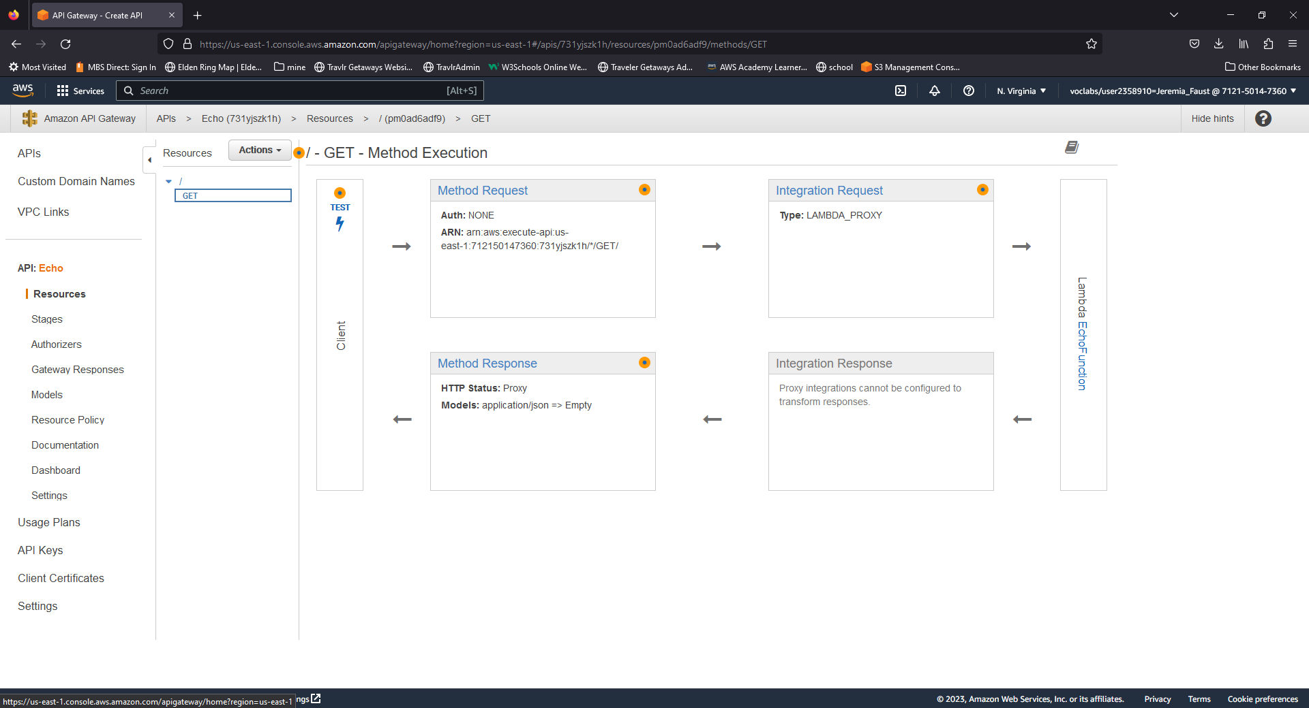

## Testing Your API to Lambda Method

Deploying Your API

